# Fur-minder

# Team members

## Sarah Jorissen, Laura Lopez, Jonathon Hoffman

# Changes and Deviations

## Changes for the Task List Component:

According to requirement 1.1.1.3 on our requirements document, a user will be asked to fill in the date and time that a task is due when they are creating an initial task. This requirement has been updated, as it no longer will require a time slot. This will also affect requirement 2.3.1.1.3 and 2.4.1.1.3 as the time slot will no longer be able to be edited. Pet deterioration will be based on the date alone and the time that has passed without completing the task. Requirement 1.1.4.3 promises that the user will be able to select a custom option to repeat the created task. This will instead be replaced by a “none” option that will allow the user to not repeat the task at all. In sum, the user will be given the option to repeat their tasks daily, weekly, or not at all.

## Changes for the Calendar Component:

According to requirement 2.1.2 in our previous requirements document, “There will be an ‘x’ button in the top-right hand corner of the window that will close the window when clicked,” has been updated. We now have implemented the pop-up window to be a modal, where we do not require the user to press the ‘x’ rather they can click outside the window. According to requirement 2.2.2, we have updated the requirement to that the User can see the tasks for that day automatically, rather than trying to generate the task list. We have also implemented a List view on the calendar that will show the tasks that have been stored in the calendar. Requirement 2.2.3 may also change, we have a way to add new tasks but editing the tasks has yet to be implemented. For requirement 2.3 and 2.4 we may have to revise how we are handling this due to time constraints. The plan is to have this as a inidividal component which is usable by both the calendar and task list.

## Changes to the Pet component:

The requirements for the pet module will more or less stay the same, with some minor tweaks. All changes to the pet – including name, color, species, etc. – will be done via the customization menu. To help keep track of when the pet will need to be updated from the tasks, a variable with the next date to make the appropriate updates will be stored with the pet in the database.

# Accomplishments

*Applicable to all: Cohesive styling for all components are still needing to be done

## Task List

The modals for the task list have been nearly completed. These modals include the add button to create a new task and the fields for user input within the new task form. The form consists of a name field, description field, date range selection, and repetition options for the user. Within that form, there is a cancel button already completed that closes out of the form upon selection. There is a save button that is displayed on the form but has not had functionality added to it as the tasks can not yet be saved onto a database. The next steps for the task list includes adding functionality to the save button as well as creating a modal so that the calendar can be accessed from the task list.

## Calendar

The calendar api is almost complete. The overall calendar has been implemented as a modal, so once we have our main page created we will be able to just attach the code to when the calendar symbol is clicked. The calendar can switch between weekly, daily, and a list views.. Creating events based on click from the calendar requests the user to provide a Title, Description, and the date selected will be stored as the date of the event. The next steps for the calendar component is to develop a way to grab data from the server and displaying the stored events on the calendar.

## Pet

The different pet species and ages have all been designed, and most of their individual “sprites” have been drawn and cleaned up. The remaining sprites will need to be finished, including the ones for animation frames. (These will be made from duplicating the final sprites and making minor edits for simple movement.) The accessories need to be designed and all images will need to be organized into their appropriate sprite sheets to be properly animated.

Once the pet display and animation has been successfully implemented, then I will implement the proper changes to the pet based on its age and health.

# Project Diagrams

## BLOCK DIAGRAM

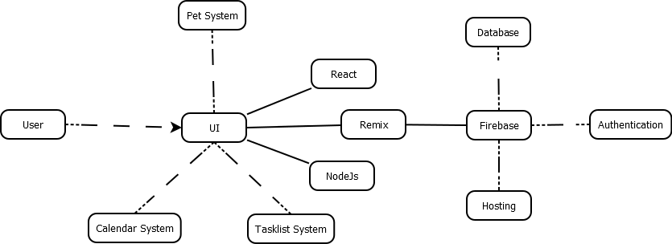

## COMPONENT DIAGRAM

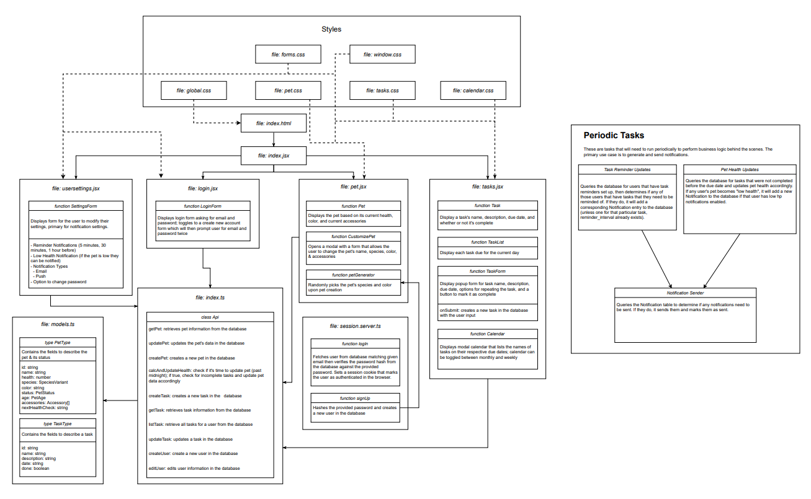

## USER INTERFACE STORYBOARD

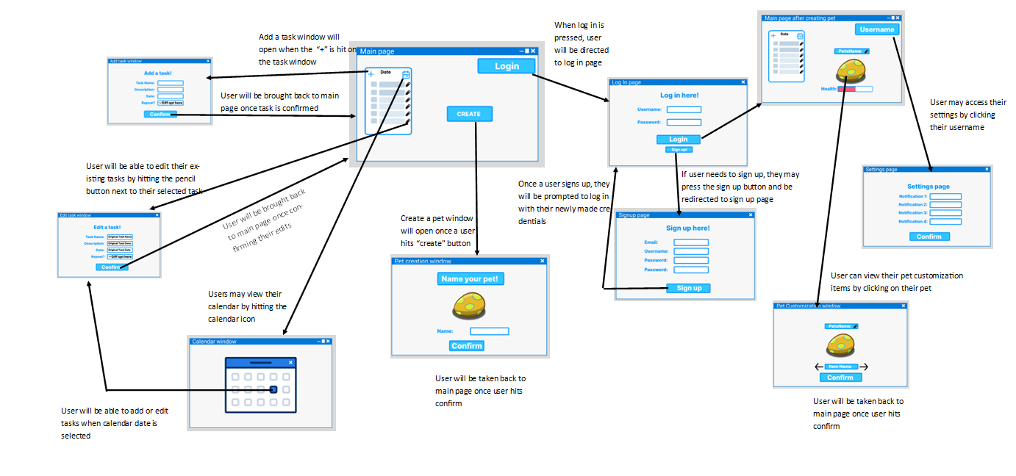

## STORAGE DOCUMENTATION

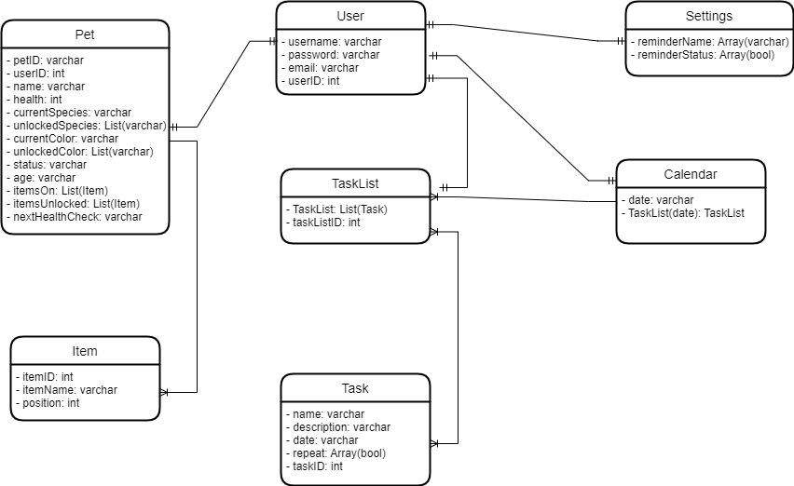

## Adult Pet Sprites

